
MALNAD COLLEGE OF ENGINEERING
(AN AUTONOMOUS INSTITUTION UNDER VTU, BELAGAVI)
HASSAN, KARNATAKA 573202, INDIA



Department of Computer Science and Engineering

NETWORK LABORATORY MANUAL
CS705

NETWORKS LABORATORY
Course Code |  |  | : CS705 |  |  |  | L-T-P-C |  |  | : 0-0-1.5-1.5
Exam Hours |  |  | : 3 |  |  |  | Hours / Week |  |  | : 3
SEE |  |  | : 50 Marks |  |  |  | Total Hours |  |  | : 40
Course Objective : |  |  |  | Students will be able to Design, develop, analyze and compare various topologies and protocols using a simulator.
Course Outcomes (COs) : |  |  |  |  | Upon completion of the course, students shall be able to:
COs |  | Statement |  |  |  |  |  |  | POs
 |  | Demonstrate the basic concepts of Classes, Networking and are documented |  |  |  |  |  |  | PO2,PO6,PO10
 |  | Execute the socket programming and networking using network simulators and are documented. |  |  |  |  |  |  | PO2,PO6,PO10
 |  | Depict built-in networking modules and design user defined topologies and modules |  |  |  |  |  |  | PO2,PO6,PO8
Course Contents:
Following set of programs are given for execution in lab, which will be helpful in understanding the basics of programming and serves as base for execution of Exercise Programs. These programs are not considered for CIE and SEE, but carry 10 marks that will be included with record mark. Cryptographic program needs to be executed in c/c++ and simulation programs in NS2 tool.
PRACTICE PROGRAMS (SELF STUDY COMPONENT)
Write and execute Programs for the below given problems before executing the corresponding programs of Exercise Part.
 | Write and execute a program for error detecting code using CRC-CCITT (16- bits).
 | Write and execute a program for congestion control using leaky bucket algorithm.
 | Simulate a three nodes point – to – point network with duplex links between them. Set the queue size and vary the bandwidth and find the number of packets dropped.
 | Simulate a three nodes point – to – point network with duplex links between them. Set the queue size and vary the bandwidth and find the number of packets sent with different types of traffic.
EXERCISE PROGRAMS
Following set of programs are included in CIE and SEE, Students have to pick a program from lot of Programs in CIE and SEE.
 | Write and execute a program for distance vector algorithm to find the suitable path for transmission between sender and receiver and also find the appropriate path if the link has been break-down.
 | Write and execute a program to find 16-bit and 32-bit checksum Fletcher and Adler Checksum methods.
 | Using TCP/IP sockets, write a client – server program to make the client send the file name and to make the server send back the contents of the requested file if present
 | Write and execute a program for simple RSA algorithm to encrypt and decrypt the data where the input prime numbers should be very large and display all the possible values of encryption key.
 | Simulate a four node point-to-point network with the links connected as follows: n0 – n2, n1 – n2 and n2 – n3. Apply TCP agent between n0-n3 and UDP between n1-n3. Apply relevant applications over TCP and UDP agents changing the parameter and determine the number of packets sent by TCP / UDP. And also plot the throughput graph for both TCP and UDP traffic.
 | Simulate a point to point network using n nodes and set multiple traffic and plot Packet delivery ratio, End to end delay and throughput for different source / destination.
 | Simulate the transmission of ping messages over a network topology consisting of 6 nodes and find the number of packets dropped due to congestion. And also plot the Congestion graph.
 | Simulate an Ethernet LAN using n nodes (6-10), change error rate and data rate and compare throughput. And also plot the graph for different throughputs.
 | Simulate an Ethernet LAN using n nodes and set multiple traffic nodes and plot congestion window for different source / destination.
 | Simulate simple ESS and with transmitting nodes in wire-less LAN by simulation and determine the performance with respect to transmission of packets

Programs

- Write and execute a program for distance vector algorithm to find the suitable path for transmission between sender and receiver and also find the appropriate path if the link has been break-down.
Program:
#include<iostream>
#include<stdio.h>
using namespace std;
struct node {
int dist[20];
int from[20];
}route[10];
int main()
{
int dm[20][20],no;
cout<<"Enter the number of nodes"<<endl;
cin>>no;
cout<<"Enter the distance matrix"<<endl;
for(int i=0;i<no;i++)
{ for(int j=0;j<no;j++)
{ cin>>dm[i][j];
dm[i][i]=0;
route[i].dist[j]=dm[i][j];
route[i].from[j]=j;
}
}
int flag;
do{
flag=0;
for(int i=0;i<no;i++)
{ for(int j=0;j<no;j++)
{ for(int k=0;k<no;k++)
{ if((route[i].dist[j])>(route[i].dist[k]+route[k].dist[j]))
{ route[i].dist[j]=route[i].dist[k]+route[k].dist[j];
route[i].from[j]=k;
flag=1;
}
}
}
}
}while(flag);
for(int i=0;i<no;i++)
{ cout<<"Router info for router:"<<i+1<<endl;
cout<<"Dest\tNext Hop\t Dist"<<endl;
for(int j=0;j<no;j++)
printf("%d\t%d\t\t%d\n",j+1,route[i].from[j]+1,route[i].dist[j]);
}
return 0;
}
Output:
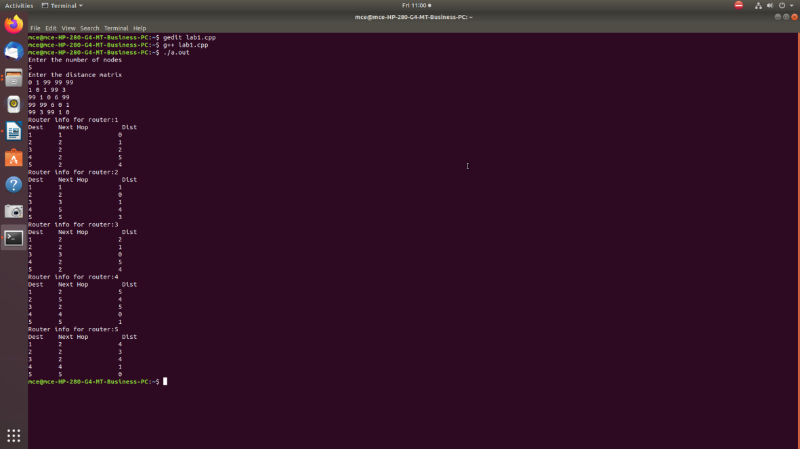

- Write and execute a program to find 16-bit and 32-bit checksum Fletcher and Adler Checksum methods
Program:
#include <iostream>
#include<inttypes.h>
#include<stdio.h>
#include<stdint.h>
#include<stdio.h>

using namespace std;
const uint32_t MOD_ADLER = 65521;

uint32_t adler32(unsigned char *data, size_t len)
/*
where data is the location of the data in physical memory and
len is the length of the data in bytes
*/
{
uint32_t a = 1;
uint32_t b = 0;
size_t index;

// Process each byte of the data in order
for (index = 0; index < len; ++index)
{
a = (a + data[index]) % MOD_ADLER;
b = (b + a) % MOD_ADLER;
}

return (b << 16) | a;
}
uint16_t Fletcher16( uint8_t *data, int count )
{
uint16_t sum1 = 0;
uint16_t sum2 = 0;
int index;

for ( index = 0; index < count; ++index )
{
sum1 = (sum1 + data[index]) % 255;
sum2 = (sum2 + sum1) % 255;
}

return (sum2 << 8) | sum1;
}
int main()
{ uint8_t data[20];
cout<<"Enter data\n";
cin>>data;
uint16_t fletcher;
uint32_t adler;
fletcher=Fletcher16(data,16);
adler=adler32(data,32);
cout<<"Adler checksum for "<<data<<" is "<<adler;
cout<<"\nFetcher checksum for "<<data<<" is "<<fletcher;
}
Output:

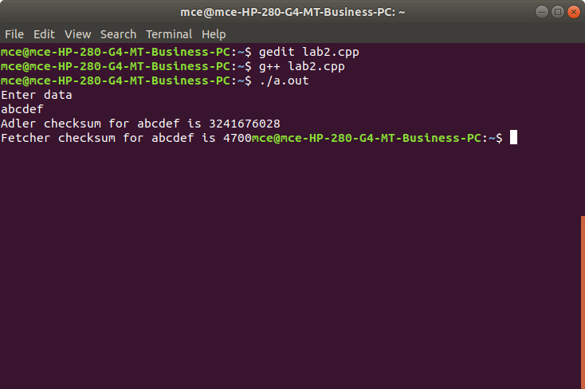

- Using TCP/IP sockets, write a client – server program to make the client send the file name and to make the server send back the contents of the requested file if present
Client.c
#include<stdio.h>
#include<stdlib.h>
#include<strings.h>
#include<string.h>
#include<sys/types.h>
#include<sys/socket.h>
#include<netinet/in.h>
#include<sys/fcntl.h>
#include<arpa/inet.h>

int main(int argc, char*argv[])
{
int sockfd,portno,n;
struct sockaddr_in serv_addr;
char buffer[4096],*servip;
if(argc<4)
{
fprintf(stderr,"usage%s serverip filename port\n",argv[0]);
exit(0);
}
servip=argv[1];
portno=atoi(argv[3]);
sockfd=socket(AF_INET,SOCK_STREAM,0);
if(sockfd<0)
perror("error openingt socket");
printf("Client Online\n");
bzero((char*)&serv_addr,sizeof(serv_addr));
serv_addr.sin_family=AF_INET;
serv_addr.sin_addr.s_addr=inet_addr(servip);
serv_addr.sin_port=htons(portno);
if(connect(sockfd,(struct sockaddr*)&serv_addr,sizeof(serv_addr))<0)
perror("error connecting");
write(sockfd,argv[2],strlen(argv[2])+1);
bzero(buffer,4096);
n=read(sockfd,buffer,4096);
if(n<=0)
{
perror("file not found");
exit(0);
}
write(1,buffer,n);
}

Server.c
#include<stdio.h>
#include<stdlib.h>
#include<strings.h>
#include<sys/types.h>
#include<sys/socket.h>
#include<netinet/in.h>
#include<sys/fcntl.h>
int main(int argc, char*argv[])
{
int fd,sockfd,newsockfd,clilen,portno,n;
struct sockaddr_in serv_addr,cli_addr;
char buffer[4096];
if(argc<2)
{
fprintf(stderr,"no port\n");
exit(1);
}
portno=atoi(argv[1]);
sockfd=socket(AF_INET,SOCK_STREAM,0);
if(sockfd<0)
error("error opening socket");
bzero((char*)&serv_addr,sizeof(serv_addr));
serv_addr.sin_family=AF_INET;
serv_addr.sin_addr.s_addr=(htonl)INADDR_ANY;
serv_addr.sin_port=htons(portno);
if(bind(sockfd,(struct sockaddr*) &serv_addr,sizeof(serv_addr))<0)
perror("error bindind");
listen(sockfd,5);
clilen=sizeof(cli_addr);
printf("SERVER Waiting for CLIENT ....\n");
while(1)
{ newsockfd=accept(sockfd,(struct sockaddr*) &cli_addr,&clilen);
if(newsockfd<0)
perror("error on accept");
bzero(buffer,4096);
read(newsockfd,buffer,4096);
fd=open(buffer,O_RDONLY);
if(fd<0)
{ write(newsockfd,"file does not exist in server",30);
perror("File not found");
exit(0);
}
else
{ while(1)
{ n=read(fd,buffer,4096);
if(n<=0)
exit(0);
write(newsockfd,buffer,n);
printf("Transfer completed\n");
}
close(fd);
close(newsockfd);
}
}
return 0;
}

To execute :
Run Server program first then client program
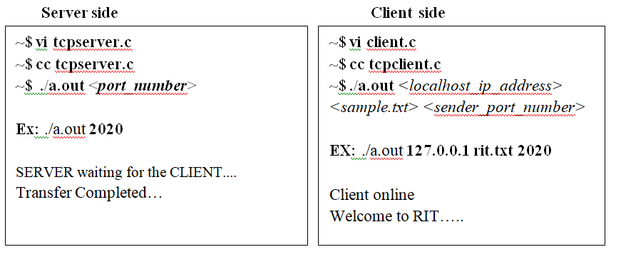
Output:
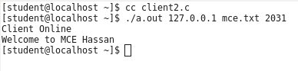
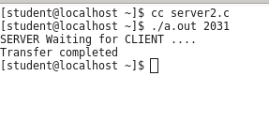

- Write and execute a program for simple RSA algorithm to encrypt and decrypt the data where the input prime numbers should be very large and display all the possible values of encryption key.
Program:
#include<iostream>
#include<stdlib.h>
#include<math.h>
#include<string.h>
using namespace std;
long int gcd(long int a, long int b)
{ if(a==0)
return b;
if(b==0)
return a;
return gcd(b,a%b);
}
long int isprime(long int a)
{
int i;
for(i=2;i<a;i++)
{ if((a%i)==0)
return 0;
}
return 1;
}
long int encrypt( char ch, long int n,long int e)
{ int i;
long int temp=ch;
for(i=1;i<e;i++)
temp=(temp*ch)%n;
return temp;
}
char decrypt(long int ch,long int n, long int d)
{ int i;
long int temp=ch;
for(i=1;i<d;i++)
ch=(temp*ch)%n;
return ch;
}
int main()
{
long int i,len;
long int p,q,n,phi,e,d,cipher[50];
char text[50];
cout<<"Enter the text to be encrypted:";
cin.getline(text,sizeof(text));
len=strlen(text);
do
{ p=rand()%30;
}while(!isprime(p));
do{ q=rand()%30;
}while(!isprime(q));
n=p*q;
phi=(p-1)*(q-1);
do{ e=rand()%phi;
}while(gcd(phi,e)!=1);
do{ d=rand()%phi;
}while(((d*e)%phi)!=1);
cout<<"two prime number (p and q) are:"<<p<<" and "<<q<<endl;
cout<<"n(p*q)="<<p<<"*"<<q<<"="<<p*q<<endl;
cout<<"(p-1)*(q-1)="<<phi<<endl;
cout<<"Public key (n,e)("<<n<<","<<e<<")\n";
cout<<"Private key (n,d):("<<n<<","<<d<<")\n";
for(i=0;i<len;i++)
cipher[i]=encrypt(text[i],n,e);
cout<<"Encrypt message:";
for(i=0;i<len;i++)
cout<<cipher[i];
for(i=0;i<len;i++)
text[i]=decrypt(cipher[i],n,d);
cout<<endl;
cout<<"Decrypted Message:";
for(i=0;i<len;i++)
cout<<text[i];
cout<<endl;
return 0;
}
Output: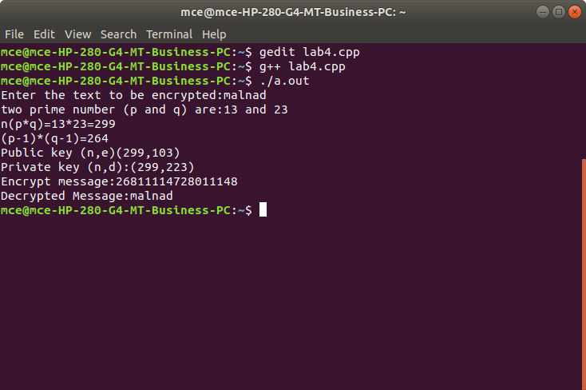

- Simulate a four node point-to-point network with the links connected as follows: n0 – n2, n1 – n2 and n2 – n3. Apply TCP agent between n0-n3 and UDP between n1-n3. Apply relevant applications over TCP and UDP agents changing the parameter and determine the number of packets sent by TCP / UDP. And also plot the throughput graph for both TCP and UDP traffic
Program:
lab5.tcl
set ns [new Simulator]
set ntrace [open lab5.tr w]
$ns trace-all $ntrace
set file3 [open lab5.nam w]
$ns namtrace-all $file3
proc finish {} {
global ns ntrace
$ns flush-trace
close $ntrace
exec nam lab5.nam &
exit 0
}
set n0 [$ns node]
set n1 [$ns node]
set n2 [$ns node]
set n3 [$ns node]
$ns duplex-link $n0 $n2 10Mb 1ms DropTail
$ns duplex-link $n2 $n3 10Mb 1ms DropTail
$ns duplex-link $n2 $n1 10Mb 1ms DropTail
$ns queue-limit $n0 $n2 10
$ns queue-limit $n1 $n2 10
set tcp0 [new Agent/TCP]
$ns attach-agent $n0 $tcp0
set sink0 [new Agent/TCPSink]
$ns attach-agent $n3 $sink0
set ftp0 [new Application/FTP]
$ftp0 attach-agent $tcp0
set udp0 [new Agent/UDP]
$ns attach-agent $n1 $udp0
set null0 [new Agent/Null]
$ns attach-agent $n3 $null0
set cbr0 [new Application/Traffic/CBR]
$cbr0 attach-agent $udp0
$ns connect $tcp0 $sink0
$ns connect $udp0 $null0
$ns at 0.0 "$ftp0 start"
$ns at 0.2 "$cbr0 start"
$ns at 0.8 "finish"
$ns run
AWK file:(Open a new editor using “vi command” and write awk file and save with “.awk” extension)
lab5.awk
BEGIN{
d=0;
tcp=0;
udp=0;
pkt_t=0;
time_t=0;
pkt_u=0;
time_u=0;
}
{
{
if(($1=="r"&& $3=="0"&& $4=="2"&& $5=="tcp")||($1=="r"&& $3=="2"&& $4=="3"&& $5=="tcp"))
{ pkt_t=pkt_t+$6;
time_t=$2;
printf("%f\t%f\n",pkt_t,time_t);
}
if(($1=="r"&& $3=="1"&& $4=="2"&& $5=="cbr")|| ($1=="r"&& $3=="2"&& $4=="3"&& $5=="cbr"))
{ pkt_u=pkt_u+$6;
time_u=$2;
printf("%f\t%f\n",pkt_u,time_u);
}
}
}

END{
printf("Throughput of TCP :%f Mbps\n",((pkt_t/time_t)*(8/1000000)));
printf("Throughput of UDP :%f Mbps\n",((pkt_u/time_u)*(8/1000000)));
}

Commands for execution:
- To open tcl file : #gedit filename.tcl
- To run tcl file : #ns filename.tcl
- To open awk file : #gedit filename.awk
- To run awk file and save contents in trace file: awk –f filename.awk filename.tr
- To plot the graph : awk –f filename.awk filename.tr >a1
- Open the file a1. Remove the last two lines which contains the throughput statements and save the file
- To display graph # xgraph a1
Output:
1. Simulator

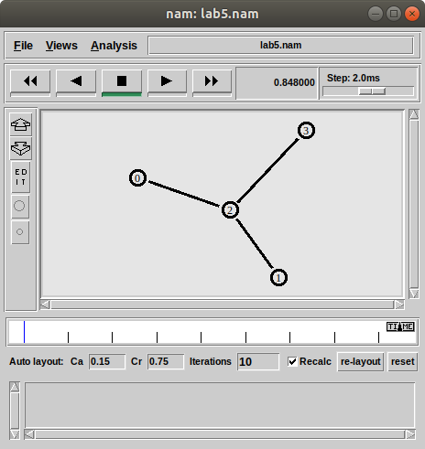

2. Awk file output

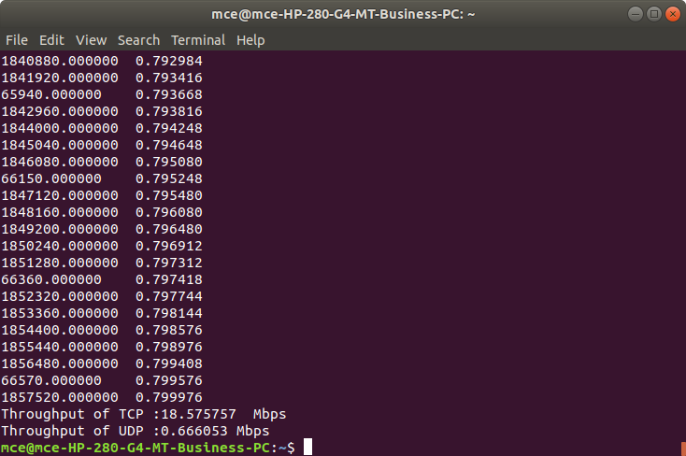
3. Graph

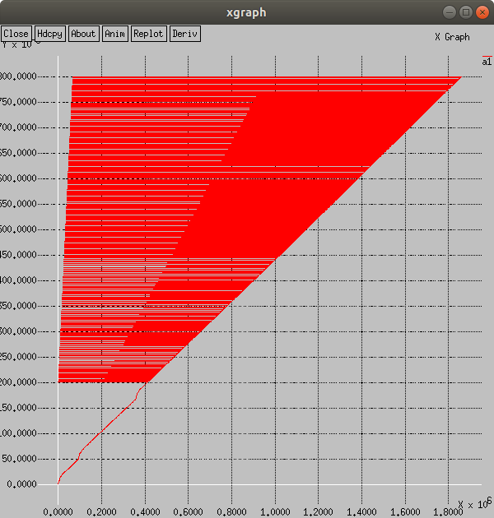
- Simulate a point-to-point network using n nodes and set multiple traffic and plot Packet delivery ratio , End to End delay and throughput for different source/destination.
Program:
set ns [new Simulator]
set nf [open first.nam w]
$ns namtrace-all $nf
set tf [open p6.tr w]
$ns trace-all $tf
proc finish {} {
global ns nf tf
$ns flush-trace
close $nf
close $tf
exec nam first.nam &
exit 0
}
set n0 [$ns node]
$n0 label "s"
set n1 [$ns node]
$n1 label "d"
set n2 [$ns node]
$n2 label "i1"
set n3 [$ns node]
$n3 label "i2"
$ns duplex-link $n0 $n2 10Mb 1ms DropTail
$ns duplex-link $n1 $n2 10Mb 1ms DropTail
$ns duplex-link $n2 $n3 10Mb 1ms DropTail
set tcp0 [new Agent/TCP]
$ns attach-agent $n0 $tcp0
set udp1 [new Agent/UDP]
$ns attach-agent $n1 $udp1
set null0 [new Agent/Null]
$ns attach-agent $n3 $null0
set sink0 [new Agent/TCPSink]
$ns attach-agent $n3 $sink0
set ftp0 [new Application/FTP]
$ftp0 attach-agent $tcp0
set cbr1 [new Application/Traffic/CBR]
$cbr1 attach-agent $udp1
$ns connect $tcp0 $sink0
$ns connect $udp1 $null0
$ns at 0.1 "$cbr1 start"
$ns at 0.1 "$ftp0 start"
$ns at 0.5 "finish"
$ns run

Awk file:
Throughput.awk
BEGIN{
d=0;
tcp=0;
udp=0;
pkt_t=0;
time_t=0;
pkt_u=0;
time_u=0;
}
{
{
if(($1=="r"&& $3=="0"&& $4=="2"&& $5=="tcp")||($1=="r"&& $3=="2"&& $4=="3"&& $5=="tcp"))
{ pkt_t=pkt_t+$6;
time_t=$2;
printf("%f\t%f\n",pkt_t,time_t);
}
if(($1=="r"&& $3=="1"&& $4=="2"&& $5=="cbr")|| ($1=="r"&& $3=="2"&& $4=="3"&& $5=="cbr"))
{ pkt_u=pkt_u+$6;
time_u=$2;
printf("%f\t%f\n",pkt_u,time_u);
}
}
}
END{
printf("Throughput of TCP :%f Mbps\n",((pkt_t/time_t)*(8/1000000)));
}

2.End to End delay
BEGIN {
a=0.0;
s=0.0;
n=0;
e=0;
}
{
if($3 == "0"&& $4=="2")
{
n++;
}
if($3 == "0"&& $1=="+")
{
a=a+$2;
}
if($1=="r")
{
s=s+$2;
}
e=(a-s)/n;
printf("%d\t%d\n", a,s);
}
END {
printf("arrival time=%f\n",a);
printf("sent time=%f\n",s );
printf("End to ENd delay=%f for %d connections\n",e,n);
}
3. PDR.awk
BEGIN{
pdr=0.0;
s=0.0;
r=0.0;
}
{ {
if($1=="+")
{ s++;
}
else if($1=="r")
{ r++;
}
pdr=r/s;
}
}
END{
printf("Sent=%d\n",s);
printf("Recv packets=%d\n",r);
printf("PDR=%f\n",pdr);
}
Output:
1. Simulator

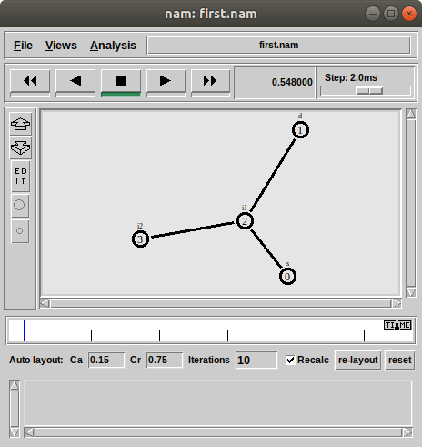

2. Awk file output
- Packet delivery ratio
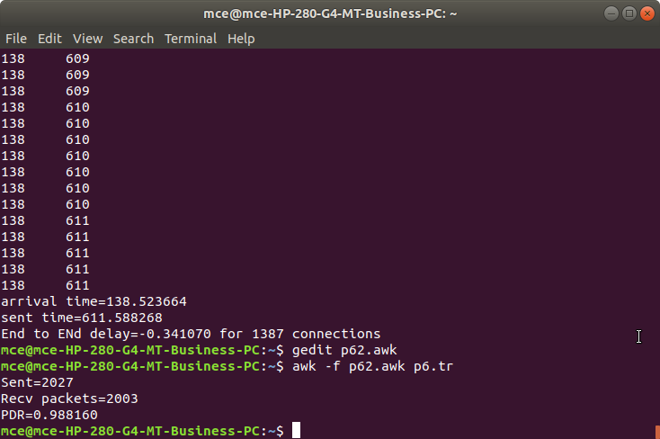

- End to end delay
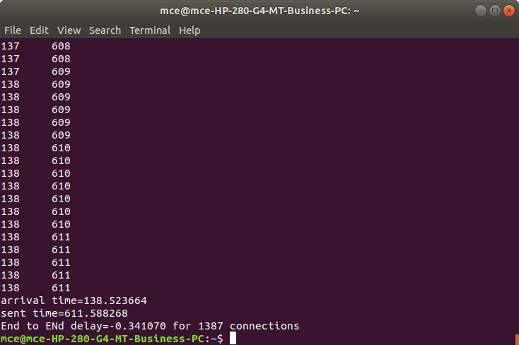
- Throughput

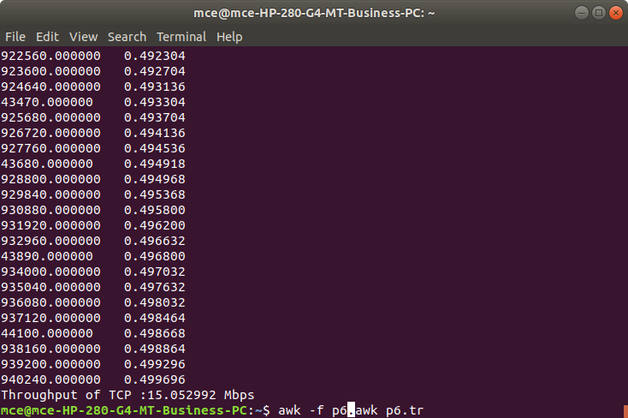

- Simulate the transmission of ping messages over a network topology consisting of 6 nodes and find the number of packets dropped due to congestion. And also plot the Congestion graph.

set ns [new Simulator]
set nf [open lab7.nam w]
$ns namtrace-all $nf
set tf [open lab7.tr w]
$ns trace-all $tf
set n0 [$ns node]
set n1 [$ns node]
set n2 [$ns node]
set n3 [$ns node]
set n4 [$ns node]
set n5 [$ns node]
$ns duplex-link $n0 $n4 1005Mb 1ms DropTail
$ns duplex-link $n1 $n4 50Mb 1ms DropTail
$ns duplex-link $n2 $n4 2000Mb 1ms DropTail
$ns duplex-link $n3 $n4 200Mb 1ms DropTail
$ns duplex-link $n4 $n5 1Mb 1ms DropTail
set p1 [new Agent/Ping]
$ns attach-agent $n0 $p1
$p1 set packetSize_ 50000
$p1 set interval_ 0.0001
set p2 [new Agent/Ping]
$ns attach-agent $n1 $p2
set p3 [new Agent/Ping]
$ns attach-agent $n2 $p3
$p3 set packetSize_ 30000
$p1 set interval_ 0.00001
set p4 [new Agent/Ping]
$ns attach-agent $n3 $p4
set p5 [new Agent/Ping]
$ns attach-agent $n5 $p5
$ns queue-limit $n0 $n4 5
$ns queue-limit $n2 $n4 3
$ns queue-limit $n4 $n5 2
Agent/Ping instproc recv { from rtt } {
$self instvar node_
puts "node [ $node_ id ] recieved answer from $from with round trip time $rtt msec"
}
$ns connect $p1 $p5
$ns connect $p3 $p4
proc finish {} {
global ns nf tf
$ns flush-trace
close $nf
exec nam lab7.nam &
exit 0
}
$ns at 0.1 "$p1 send"
$ns at 0.2 "$p1 send"
$ns at 0.3 "$p1 send"
$ns at 0.4 "$p1 send"
$ns at 0.5 "$p1 send"
$ns at 0.6 "$p1 send"
$ns at 0.7 "$p1 send"
$ns at 0.8 "$p1 send"
$ns at 0.9 "$p1 send"
$ns at 1.0 "$p1 send"
$ns at 1.1 "$p1 send"
$ns at 1.2 "$p1 send"
$ns at 1.3 "$p1 send"
$ns at 1.4 "$p1 send"
$ns at 1.5 "$p1 send"
$ns at 1.6 "$p1 send"
$ns at 1.7 "$p1 send"
$ns at 1.8 "$p1 send"
$ns at 1.9 "$p1 send"
$ns at 2.0 "$p1 send"
$ns at 2.1 "$p1 send"
$ns at 2.2 "$p1 send"
$ns at 2.3 "$p1 send"
$ns at 2.4 "$p1 send"
$ns at 2.5 "$p1 send"
$ns at 2.6 "$p1 send"
$ns at 2.7 "$p1 send"
$ns at 2.8 "$p1 send"
$ns at 2.9 "$p1 send"
$ns at 0.1 "$p3 send"
$ns at 0.2 "$p3 send"
$ns at 0.3 "$p3 send"
$ns at 0.4 "$p3 send"
$ns at 0.5 "$p3 send"
$ns at 0.6 "$p3 send"
$ns at 0.7 "$p3 send"
$ns at 0.8 "$p3 send"
$ns at 0.9 "$p3 send"
$ns at 1.0 "$p3 send"
$ns at 1.1 "$p3 send"
$ns at 1.2 "$p3 send"
$ns at 1.3 "$p3 send"
$ns at 1.4 "$p3 send"
$ns at 1.5 "$p3 send"
$ns at 1.6 "$p3 send"
$ns at 1.7 "$p3 send"
$ns at 1.8 "$p3 send"
$ns at 1.9 "$p3 send"
$ns at 2.0 "$p3 send"
$ns at 2.1 "$p3 send"
$ns at 2.2 "$p3 send"
$ns at 2.3 "$p3 send"
$ns at 2.4 "$p3 send"
$ns at 2.5 "$p3 send"
$ns at 2.6 "$p3 send"
$ns at 2.7 "$p3 send"
$ns at 2.8 "$p3 send"
$ns at 2.9 "$p3 send"
$ns at 3.0 finish
$ns run

Awk File:
BEGIN{
drop=0;
}
{
if($1=="d")
{ drop++;
}
}
END{
printf("Total number of %s packets dropped due to congestion =%d \n",$5,drop);
}
Output:
1. Simulator

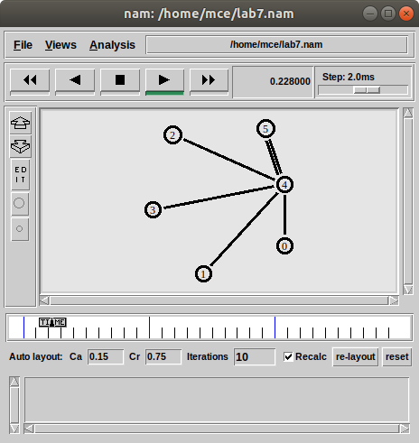

2. Awk file output
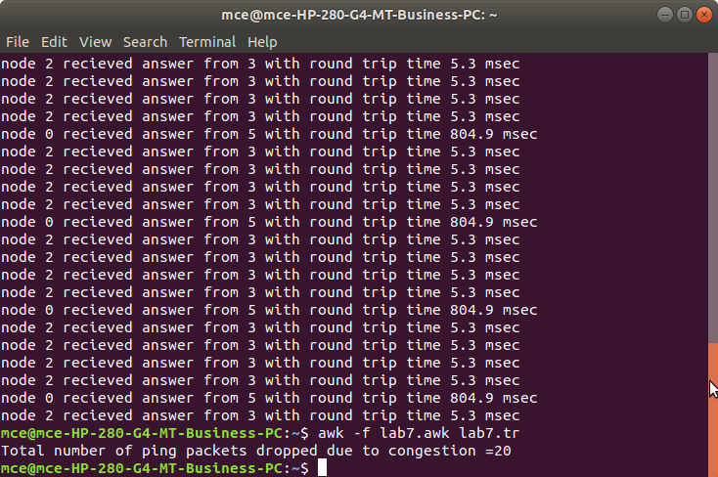

- Simulate an Ethernet LAN using n nodes (6-10), change error rate and data rate and compare throughput. And also plot the graph for different throughputs.

set ns [new Simulator]
set tf [open lab8.tr w]
$ns trace-all $tf
set nf [open lab8.nam w]
$ns namtrace-all $nf
$ns color 0 blue

set n0 [$ns node]
$n0 color "red"
set n1 [$ns node]
$n1 color "red"
set n2 [$ns node]
$n2 color "red"
set n3 [$ns node]
$n3 color "red"
set n4 [$ns node]
$n4 color "magenta"
set n5 [$ns node]
$n5 color "magenta"
set n6 [$ns node]
$n6 color "magenta"
set n7 [$ns node]
$n7 color "magenta"
$ns make-lan "$n0 $n1 $n2 $n3" 100Mb 300ms LL Queue/DropTail Mac/802_3
$ns make-lan "$n4 $n5 $n6 $n7" 100Mb 300ms LL Queue/DropTail Mac/802_3
$ns duplex-link $n3 $n4 100Mb 300ms DropTail
$ns duplex-link-op $n3 $n4 color "green"

set err [new ErrorModel]
$ns lossmodel $err $n3 $n4
$err set rate_ 0.1
set udp [new Agent/UDP]
$ns attach-agent $n1 $udp

set cbr [new Application/Traffic/CBR]
$cbr attach-agent $udp
$cbr set fid_ 0
$cbr set packetSize_ 1000
$cbr set interval_ 0.0001
set null [new Agent/Null]
$ns attach-agent $n7 $null
$ns connect $udp $null
proc finish {} {
global ns nf tf
$ns flush-trace
close $nf
close $tf
exec nam lab8.nam &
exit 0
}
$ns at 0.1 "$cbr start"
$ns at 3.0 "finish"
$ns run

Awk File
BEGIN{
pkt=0;
time=0;
}
{ if($1=="r"&& $3=="9"&& $4=="7"){
pkt=pkt+$6;
time=$2;
}
}
END{
printf("Throughput=%fMbps",((pkt/time)*(8/1000000)));
}

Output:
1. Simulator

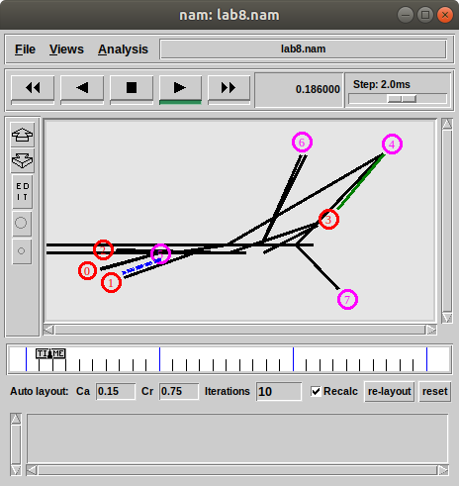

2. Awk file output

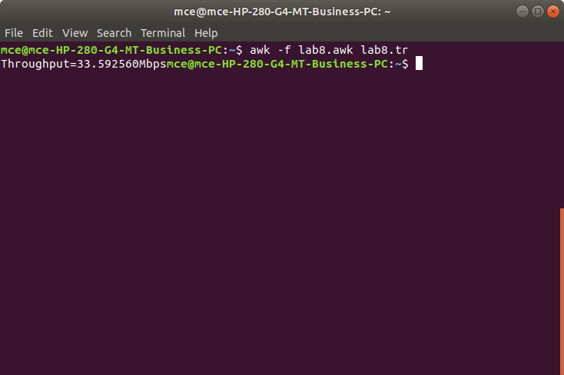

- Simulate an Ethernet LAN using n nodes and set multiple traffic nodes and plot congestion window for different source / destination.

set ns [ new Simulator]
set tf [ open lab9.tr w]
$ns trace-all $tf
set nf [open lab9.nam w]
$ns namtrace-all $nf

set n0 [$ns node]
$n0 color "magenta"
$n0 label "SRC1"
set n1 [$ns node]
set n2 [$ns node]
$n2 color "magenta"
$n2 label "SRC2"
set n3 [$ns node]
$n3 color "blue"
$n3 label "DEST2"
set n4 [$ns node]
set n5 [$ns node]
$n5 color "blue"
$n5 label "DEST1"
$ns make-lan "$n0 $n1 $n2 $n3 $n4" 100Mb 100ms LL Queue/DropTail Mac/802_3
$ns duplex-link $n4 $n5 1Mb 1ms DropTail
set tcp0 [new Agent/TCP]
$ns attach-agent $n0 $tcp0
set ftp0 [new Application/FTP]
$ftp0 attach-agent $tcp0
$ftp0 set packetSize_ 500
$ftp0 set interval_ 0.0001
set sink5 [new Agent/TCPSink]
$ns attach-agent $n5 $sink5
$ns connect $tcp0 $sink5
set tcp2 [new Agent/TCP]
$ns attach-agent $n2 $tcp2
set ftp2 [new Application/FTP]
$ftp2 attach-agent $tcp2
$ftp2 set packetSize_ 600
$ftp2 set interval_ 0.001
set sink3 [new Agent/TCPSink]
$ns attach-agent $n3 $sink3
$ns connect $tcp2 $sink3
set file1 [open file1.tr w]
$tcp0 attach $file1
set file2 [open file2.tr w]
$tcp2 attach $file2

$tcp0 trace cwnd_
$tcp2 trace cwnd_
proc finish {} {
global ns nf tf
$ns flush-trace
close $tf
close $nf
exec nam lab9.nam &
exit 0
}
$ns at 0.1 "$ftp0 start"
$ns at 5 "$ftp0 stop"
$ns at 7 "$ftp0 start"
$ns at 0.2 "$ftp2 start"
$ns at 8 "$ftp2 stop"
$ns at 14 "$ftp0 stop"
$ns at 10 "$ftp2 start"
$ns at 15 "$ftp2 stop"
$ns at 16 "finish"
$ns run

Awk File
BEGIN{
}
{ if($6=="cwnd_")
printf("%f\t%f\t\n",$1,$7);
}
END{
}
Steps for Execution
- Run Simulator
- In terminal
awk –f lab9.awk lab9.tr> a1
awk –f lab9.awk lab9.tr> a2
- To plot graph
xgraph a1 a2
Output:
1. Simulator

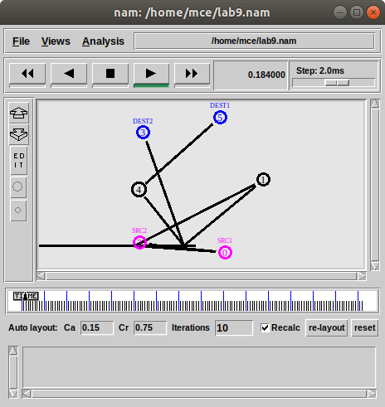

3. xgraph

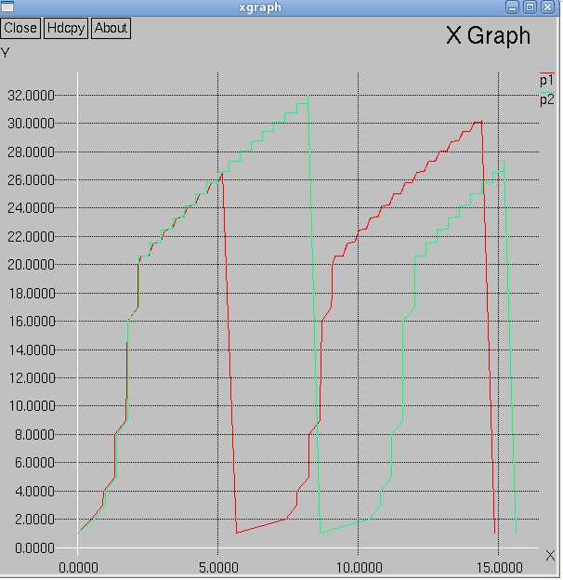

- Simulate simple ESS and with transmitting nodes in wire-less LAN by simulation and determine the performance with respect to transmission of packets.

set ns [new Simulator]
set tf [open lab10.tr w]
$ns trace-all $tf
set topo [new Topography]
$topo load_flatgrid 1000 1000
set nf [open lab10.nam w]
$ns namtrace-all-wireless $nf 1000 1000
$ns node-config -adhocRouting DSDV \
-llType LL \
-macType Mac/802_11 \
-ifqType Queue/DropTail \
-ifqLen 50 \
-phyType Phy/WirelessPhy \
-channelType Channel/WirelessChannel \
-propType Propagation/TwoRayGround \
-antType Antenna/OmniAntenna \
-topoInstance $topo \
-agentTrace ON \
-routerTrace ON
create-god 3
set n0 [$ns node]
set n1 [$ns node]
set n2 [$ns node]
$n0 label "tcp0"
$n1 label "sink1/tcp1"
$n2 label "sink2"
$n0 set X_ 50
$n0 set Y_ 50
$n0 set Z_ 0
$n1 set X_ 100
$n1 set Y_ 100
$n1 set Z_ 0
$n2 set X_ 600
$n2 set Y_ 600
$n2 set Z_ 0
$ns at 0.1 "$n0 setdest 50 50 15"
$ns at 0.1 "$n1 setdest 100 100 25"
$ns at 0.1 "$n2 setdest 600 600 25"
set tcp0 [new Agent/TCP]
$ns attach-agent $n0 $tcp0
set ftp0 [new Application/FTP]
$ftp0 attach-agent $tcp0
set sink1 [new Agent/TCPSink]
$ns attach-agent $n1 $sink1
$ns connect $tcp0 $sink1
set tcp1 [new Agent/TCP]
$ns attach-agent $n1 $tcp1
set ftp1 [new Application/FTP]
$ftp1 attach-agent $tcp1
set sink2 [new Agent/TCPSink]
$ns attach-agent $n2 $sink2
$ns connect $tcp1 $sink2
$ns at 5 "$ftp0 start"
$ns at 5 "$ftp1 start"
$ns at 100 "$n1 setdest 550 550 15"
$ns at 190 "$n1 setdest 70 70 15"
proc finish {} {
global ns nf tf
$ns flush-trace
exec nam lab10.nam &
close $tf
close $nf
exit 0awk
}
$ns at 250 "finish"
$ns run

Awk File:
BEGIN{
count1=0;
count2=0;
pack1=0;
pack2=0;
time1=0;
time2=0;
}
{ if($1=="r"&& $3=="_1_"&& $4=="AGT")
{ count1++;
pack1=pack1+$8;
time1=$2;
}
if($1=="r"&& $3=="_2_"&& $4=="AGT")
{ count2++;
pack2=pack2+$8;
time2=$2;
}
}
END{
printf("The Throughput from n0 to n1: %f Mbps\n",((count1*pack1*8)/(time1*1000000)));
printf("The Throughput from n1 to n2: %f Mbps\n",((count2*pack2*8)/(time2*1000000)));
}

Output:
      - Simulator

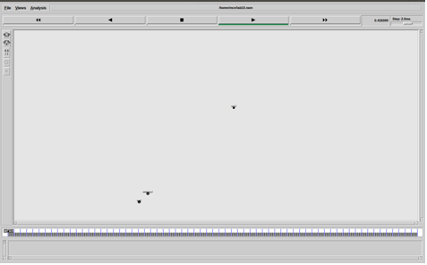
2. Awk file output

